**Definition:**centrifugal pump is a mechanical device to move fluids, the pump is composed from rotary motor and an impeller, the fluid gains an increase in both pressure and velocity after passing through the pump.

**Mechanism of a Basic Pump:**

The rotating impeller is sandwiched between two plates, such that the center of the impeller is accessible to fluids, this is the inlet. Upon rotation the fluid is pushed into the circumference of the impeller, certain casing geometry help harvest the rotational power supplied by the impeller. The plates are introduced around the impeller to force the fluid into the impeller’s circumference and not along the axis of rotation.

**Pump Casing:**

Mainly there are two designs volute and diffuser. The casing main objective is to discharge the fluid out of the pump.

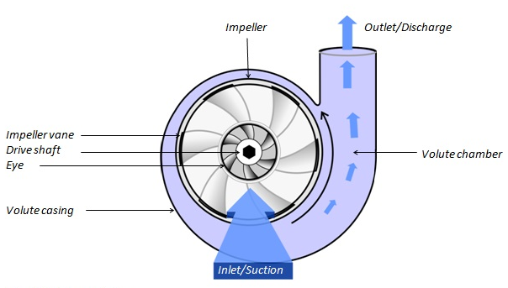

Figure : Volute Pump Casing

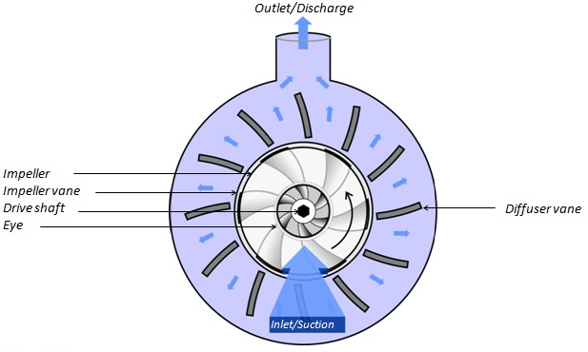

Figure : Diffuser Pump Casing

**Main Features of Centrifugal Pump:**

They’re the most used type of pump (the only other type being positive displacement pump), they’re best suited for high flows and low viscosity.

**What are the Limitations of a Centrifugal Pump:**

The centrifugal pump can’t start pumping while dry, the fluid needs to be supplied to the pump first. Also it is highly inefficient when pump high viscosity fluids, as they tamper the impeller speed, the main contributor to the pump’s efficiency.